Chapter 7, Solution 18.

If 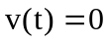, the circuit can be redrawn as shown below.

0.4 H
R_{eq}
i(t)
+
v_{o}(t)
−

 